PROJECT REPORT
Cognitive State Prediction Using
HRV-Based Biomedical Signals
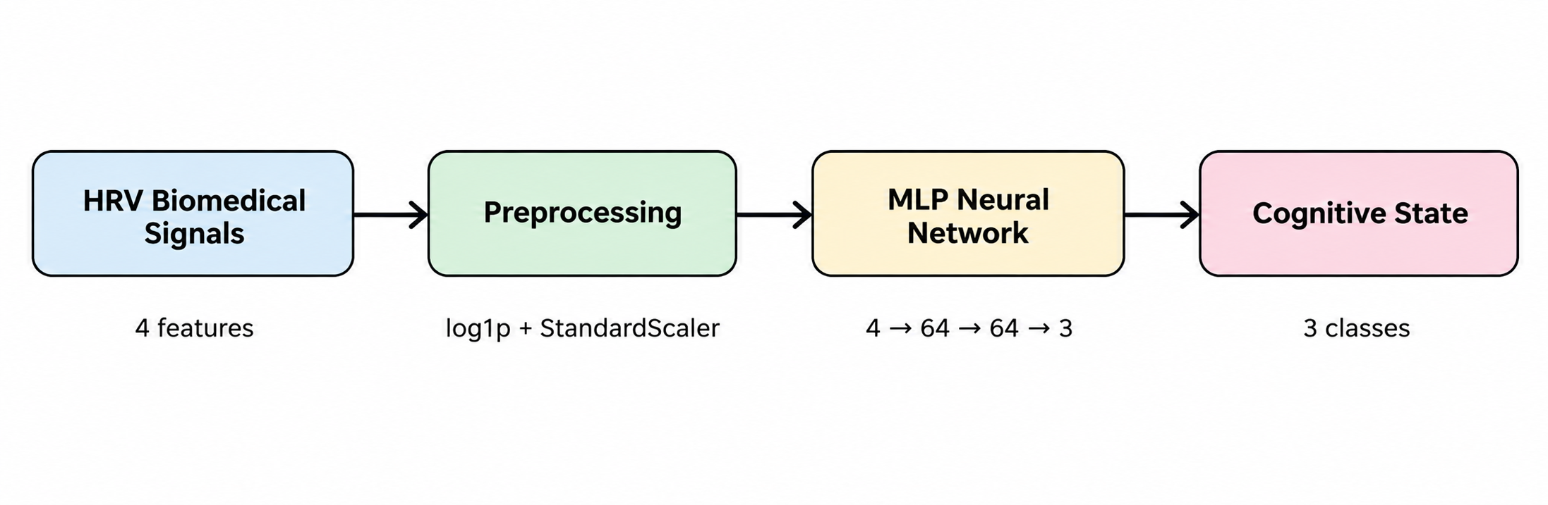
Figure 1. End-to-end workflow of the proposed system.

Project Area | Biomedical Signal Prediction
Dataset | SWELL-KW HRV dataset
Input Signals / Features | MEAN_RR, RMSSD, SDRR, LF_HF
Model | Multi-Layer Perceptron (MLP)
Output Classes | No Stress, Interruption, Time Pressure
Application | Interactive Streamlit prediction interface

Prepared as a project report

Executive Summary
This project develops a biomedical-signal-based classification system that uses Heart Rate Variability (HRV) features to predict a cognitive state. The implementation uses four HRV features—MEAN_RR, RMSSD, SDRR, and LF_HF—and classifies observations into three target states: No Stress, Interruption, and Time Pressure. The model is a compact Multi-Layer Perceptron (MLP) implemented with PyTorch.
The dataset contains 369,289 usable records after missing-value handling, with four selected input features. Because LF_HF is strongly right-skewed, a log1p transformation is applied before standardization. Class imbalance is addressed using balanced class weights in the CrossEntropyLoss function. The data is divided into 80% training and 20% testing data.
After 10 training epochs, the recorded test accuracy is 93.41%. The class-wise results show strong performance across all three states, with F1-scores of 0.95 for No Stress, 0.94 for Interruption, and 0.89 for Time Pressure. The trained model and scaler are saved together in hrv_model.pth so that the Streamlit application can load the trained model instead of retraining it for normal use.

Key Results
- Dataset size after cleaning: 369,289 records.
- Input features: 4 HRV features.
- Training/testing split: 80% / 20%.
- MLP architecture: 4 input features → 64 hidden units → 64 hidden units → 3 output classes.
- Optimizer: Adam with learning rate 0.001.
- Batch size: 64.
- Training duration: 10 epochs.
- Recorded test accuracy: 93.41%.
- Test loss: 0.1604.

1. Introduction
Biomedical signals contain physiological information that can be processed to infer human states. In this project, the focus is Heart Rate Variability (HRV), which describes variation in the time intervals between consecutive heartbeats. Instead of working directly with a raw ECG waveform, the project uses selected HRV-derived numerical features as model inputs.
The prediction task is a three-class classification problem. The model does not simply produce a binary stressed/not-stressed decision. It distinguishes between No Stress, Interruption, and Time Pressure. Therefore, the project is best described as state prediction using HRV-based biomedical signals, with the target states being related to different cognitive conditions.

1.1 Problem Statement
To develop a machine learning system that can learn patterns in HRV-based biomedical signal features and classify an observation into one of three cognitive-state categories.

1.2 Objectives
- Load and prepare the SWELL-KW HRV dataset.
- Select relevant HRV features for classification.
- Identify and address feature skewness and class imbalance.
- Build an MLP neural-network classifier using PyTorch.

2. Dataset and Data Preparation
The project uses the SWELL-KW Heart Rate Variability dataset accessed through the KaggleHub dataset identifier qiriro/swell-heart-rate-variability-hrv. The notebook loads the final training CSV and selects four HRV-related columns for the prediction task.

2.1 Selected Features
Feature | User-facing meaning | Role in model
MEAN_RR | Average time between heartbeats | Input feature
RMSSD | Short-term heartbeat variation | Input feature
SDRR | Overall RR-interval variation | Input feature
LF_HF | Low-to-high frequency HRV ratio | Input feature; log transformed
Condition | Tells if the person has No stress, Interruption or Time Pressure | Output feature

2.2 Descriptive Statistics
Feature | Count | Mean | Std. Dev. | Minimum | Maximum
MEAN_RR | 369,289 | 846.65 | 124.60 | 547.49 | 1322.02
RMSSD | 369,289 | 14.98 | 4.12 | 5.53 | 26.63
SDRR | 369,289 | 109.35 | 77.12 | 27.23 | 563.49
LF_HF | 369,289 | 115.98 | 360.86 | 2.32 | 7796.44
The descriptive statistics show that LF_HF has a particularly wide range and high standard deviation. This supports the notebook's decision to apply a logarithmic transformation to reduce its right-skewed distribution.
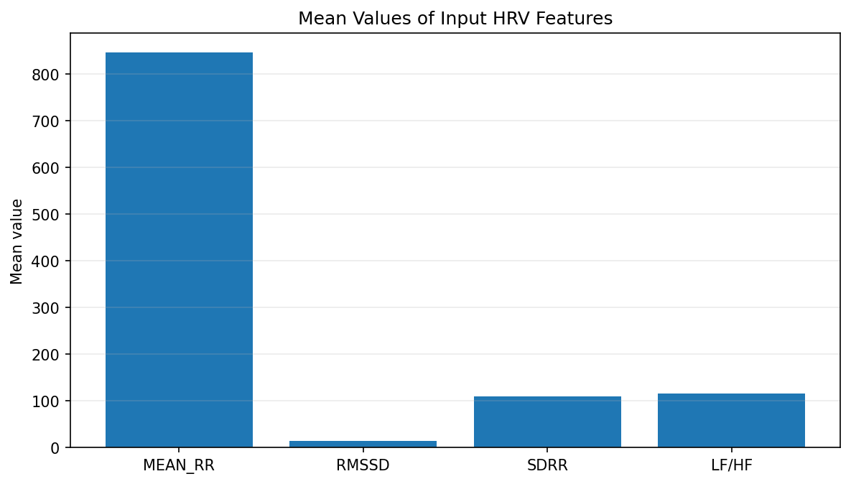
Figure 2. Mean values of the four selected HRV features.

3. Data Preprocessing and Feature Engineering

3.1 Missing-Value Handling
The dataset is cleaned using dropna(). In the recorded notebook run, the dataset shape remains 369,289 × 36 before and after this step. Four columns are then selected as model inputs.

3.2 LF_HF Logarithmic Transformation
The LF_HF feature is transformed using log1p(x), which is equivalent to log(1+x). The purpose is to reduce the influence of the long right tail and make the feature easier for the neural network to learn from. The transformed feature is then used in place of the original LF_HF.
3.2.1 Why the Log Transformation Was Important
Why it was important: LF_HF had a very wide range (2.32 to 7,796.44) and a much larger standard deviation than its mean, showing a strong right-skewed distribution. Without reducing this skew, a small number of very large values could have an excessive influence on model training. Using log1p made the feature distribution more manageable while preserving all observations, which helps the neural network learn more stable patterns from the HRV data.
3.2.2 Log Transformation Formula and Procedure

log1p(LF_HF) = ln(1 + LF_HF)

For each observation, the original LF_HF value was replaced by its transformed value. This was done before StandardScaler, so the neural network received the transformed and standardized feature.

Example
If LF_HF = 327, then log1p(327) = ln(328) ≈ 5.79. The transformed value, not the original 327, was then included in the four-feature input passed to StandardScaler.

3.3 Standardization
StandardScaler is applied to the four model features. Standardization puts the features on a comparable scale, which is important for gradient-based neural-network training because features with very different numerical ranges can otherwise dominate the optimization process.

3.4 Class Imbalance
The notebook identifies class imbalance in the target variable. Balanced class weights are calculated and passed to PyTorch's CrossEntropyLoss. The recorded weights are approximately 0.6152 for No Stress, 1.1707 for Interruption, and 1.9217 for Time Pressure. Higher weights give greater loss importance to the less represented classes.
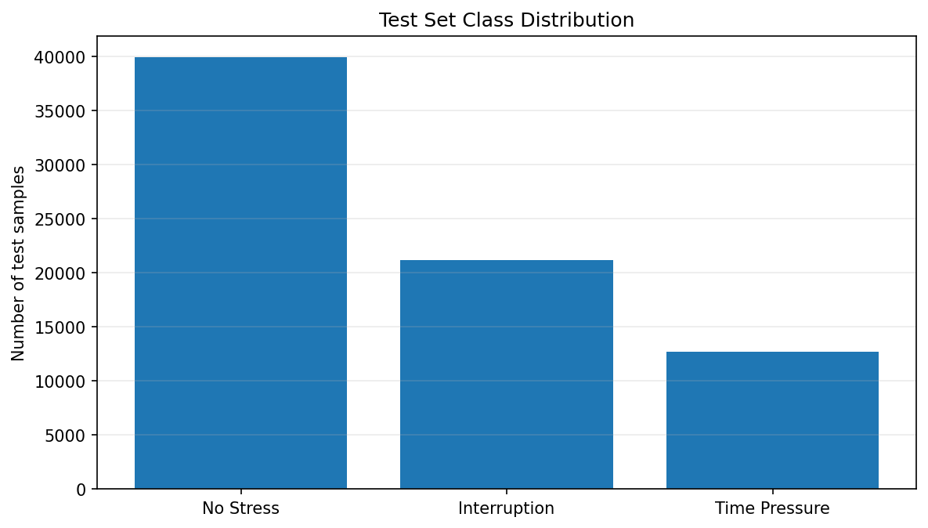
Figure 3. Distribution of the three classes in the recorded test set.

3.4.1 Class Weight Formula and Procedure

Weightᵢ = N / (K × Nᵢ)

The balanced class weights were calculated from the number of samples in each class. N represents the total number of training samples, K is the number of classes (3), and Nᵢ is the number of training samples in class i.

3.4.2 How the Weights Were Used
The calculated weights were passed directly to PyTorch's CrossEntropyLoss. The recorded weights were approximately 0.6152 for No Stress, 1.1707 for Interruption, and 1.9217 for Time Pressure. Therefore, an error on a less represented class contributes more to the loss than an error on the majority class. This helps the model learn all three classes instead of mainly favoring the most frequent class.

4. Methodology
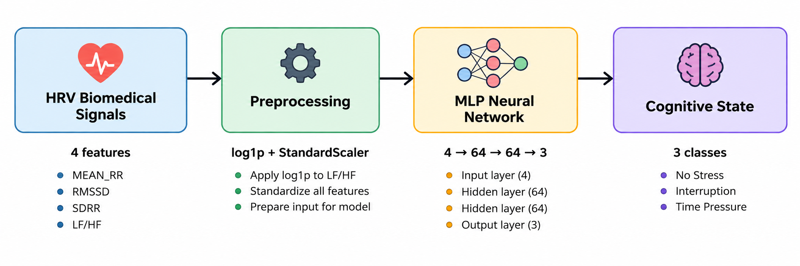
Figure 4. Processing pipeline from HRV features to predicted cognitive state.

4.1 Target Encoding
The textual target labels are encoded as numerical class indices: 0 = no stress, 1 = interruption, and 2 = time pressure. Numerical labels are required for multi-class CrossEntropyLoss in PyTorch.

4.2 Train-Test Split
The 369,289 records are divided into 295,431 training samples and 73,858 testing samples, corresponding to an 80/20 split. A batch size of 64 is used during training.

4.3 MLP Architecture
Layer | Configuration | Purpose
Input | 4 features | Receives standardized HRV features
Hidden Layer 1 | 64 neurons + ReLU | Learns non-linear feature patterns
Hidden Layer 2 | 64 neurons + ReLU | Learns higher-level combinations
Output | 3 neurons | Produces scores for the three states
The ReLU activation function introduces non-linearity, allowing the network to learn relationships that cannot be represented by a simple linear classifier. The final layer produces three output scores that are converted to class probabilities with softmax during prediction.

4.4 Training Configuration
Parameter | Value
Optimizer | Adam
Learning rate | 0.001
Batch size | 64
Epochs | 10
Loss function | Weighted Cross-Entropy Loss
Hidden size | 64

5. Model Training Results
The training log shows a substantial improvement in performance during the first few epochs. Training accuracy increases from 72.28% in epoch 1 to 93.33% in epoch 10, while test accuracy increases from 81.21% to 93.41%.
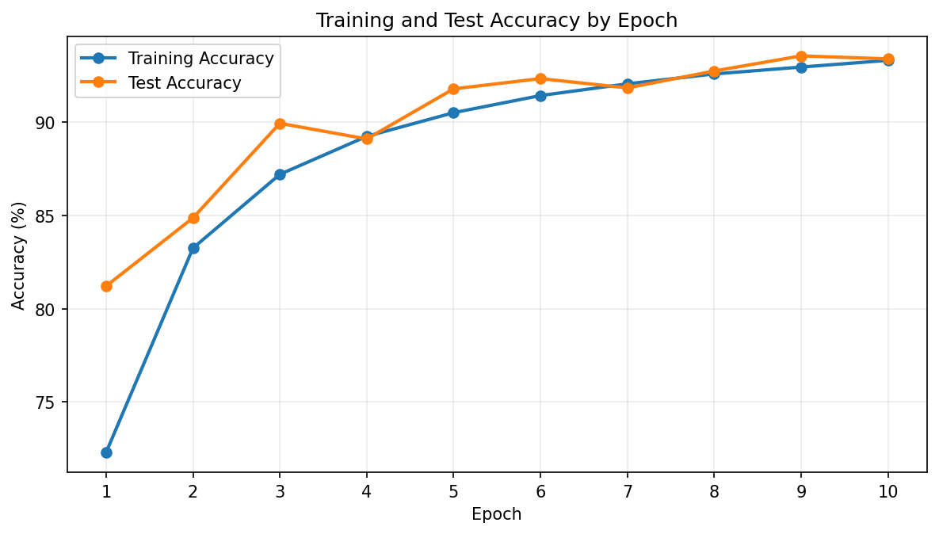
Figure 5. Training and test accuracy across 10 epochs.
The loss curves also decrease over training. Test loss reaches 0.1538 in epoch 9 and is 0.1604 in epoch 10. The small fluctuation in the final epochs is normal in neural-network training and does not by itself indicate severe overfitting.
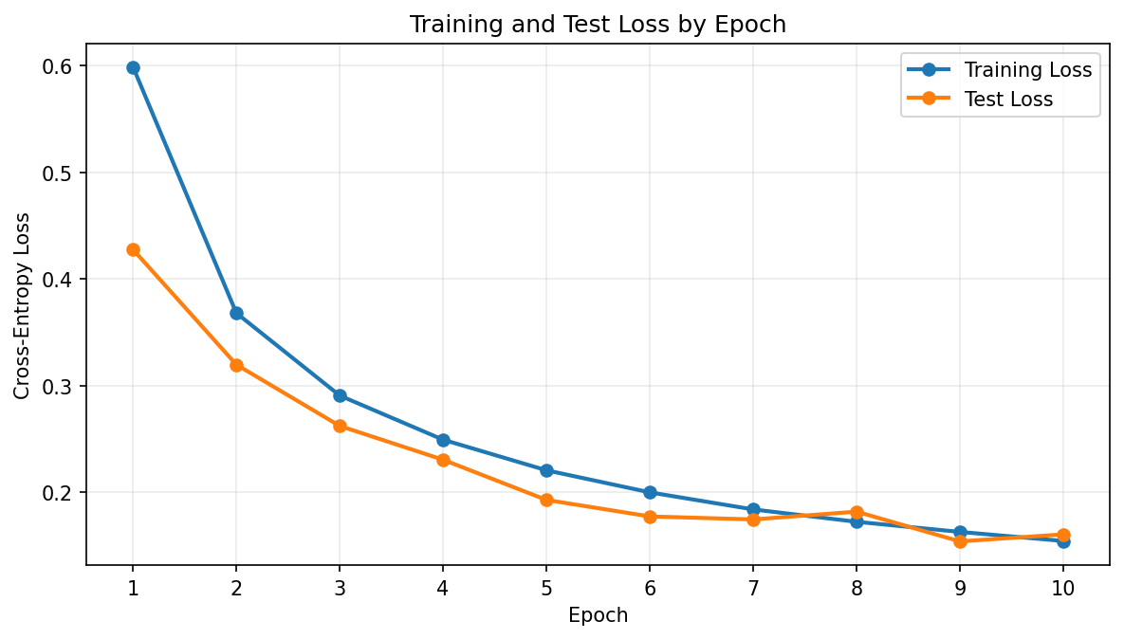
Figure 6. Training and test loss across 10 epochs.

6. Model Evaluation
The recorded final test accuracy is 93.41%. However, accuracy alone is not sufficient for a multi-class problem with unequal class sizes. The classification report therefore provides precision, recall, and F1-score for each class.
Class | Precision | Recall | F1-score | Test support
No Stress | 0.97 | 0.93 | 0.95 | 39,945
Interruption | 0.95 | 0.94 | 0.94 | 21,208
Time Pressure | 0.83 | 0.95 | 0.89 | 12,705
Overall accuracy | — | — | — | 93.41%
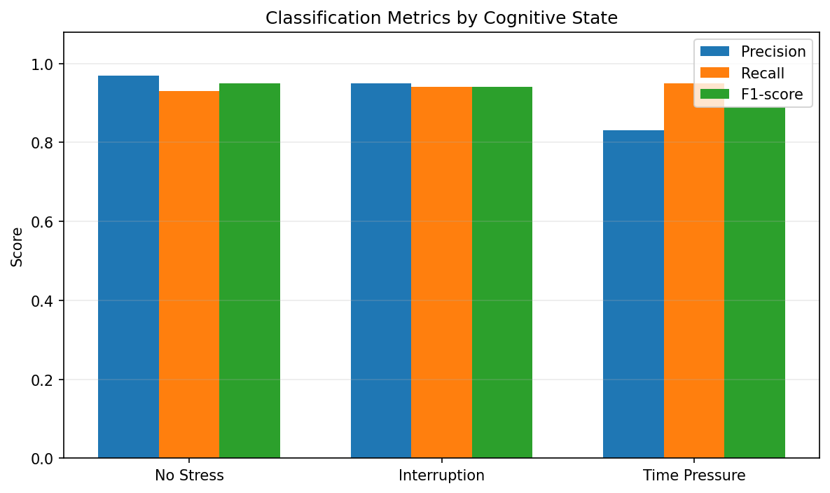
Figure 7. Precision, recall, and F1-score for each target class.

6.1 Interpretation
- No Stress has a precision of 0.97, meaning most observations predicted as No Stress are actually from that class.
- Interruption has balanced precision and recall of 0.95 and 0.94, indicating consistent performance.
- Time Pressure has the lowest precision (0.83) but high recall (0.95), meaning the model identifies most actual Time Pressure cases but also assigns some other cases to this class.
- The macro-average F1-score is 0.93, showing that performance remains strong when all three classes are considered equally.

6.2 Validation Loss
The recorded cross-entropy loss on the test set is 0.1604. This loss value complements accuracy by measuring how well the model's output scores align with the correct class labels.

7. Streamlit Application
The project includes a Streamlit interface designed for simple interaction. A normal user does not need to understand the raw feature names to use the interface: the input labels describe the features in plain language, while the technical names can be viewed through the help descriptions.

7.1 User Input
- Average Time Between Heartbeats — corresponds to MEAN_RR.
- Short-Term Heartbeat Variation — corresponds to RMSSD.
- Overall Heartbeat Variation — corresponds to SDRR.
- Low-to-High Frequency Ratio — corresponds to LF/HF.

7.2 Prediction Output
- Predicted cognitive state.
- Prediction confidence.
- Class probabilities for all three states.
- Recommended intervention mapped to the predicted state.
The application uses the same LF_HF log1p transformation and saved StandardScaler used during training. The trained model and scaler are stored in hrv_model.pth, allowing the application to load the learned parameters rather than performing the complete training workflow during normal use.
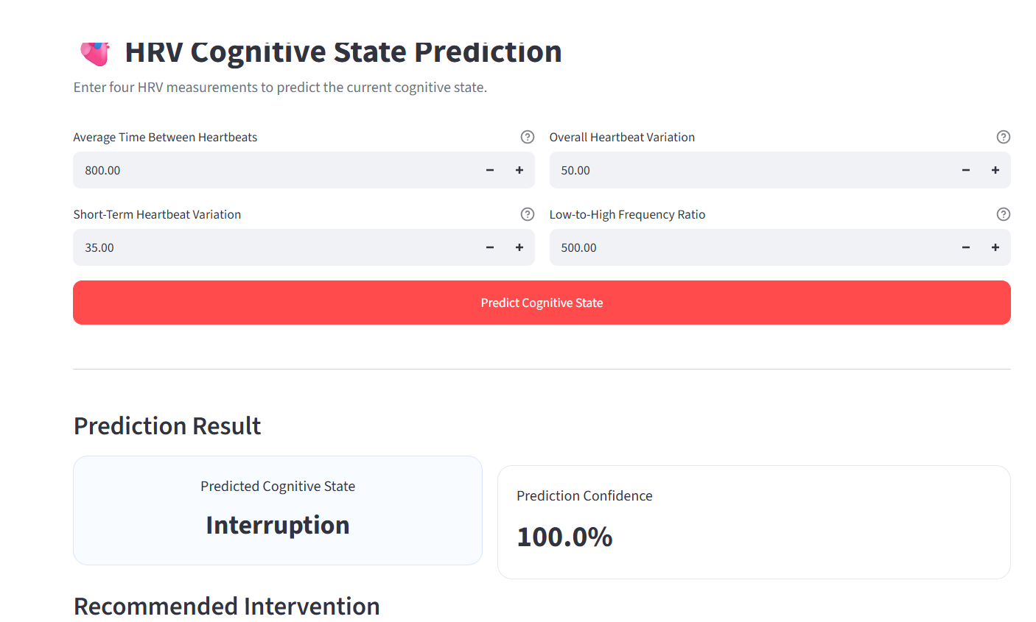
Figure 8. Streamlit prediction interface used for the project.

8. Intervention Recommendation Layer
The project adds a simple recommendation layer after classification. Each model output class is mapped to an intervention category. This converts the classification result into an actionable application output while keeping the recommendation logic separate from the neural-network model.
Predicted state | Mapped recommendation
No Stress | Focus Boosters — short meditation or a deep-work playlist.
Interruption | Mindfulness & Re-focusing — 5-minute breathing or a quick stretch.
Time Pressure | Stress Reduction & Grounding — relaxation, guided imagery, or a short break.
These recommendations are application-level mappings. They are not medical diagnoses or clinical treatments, and the model should be presented as a project-level prediction system rather than a clinical diagnostic device.

9. Model Saving and Faster Deployment
The final notebook saves the learned MLP parameters together with the fitted StandardScaler in hrv_model.pth. Saving both is important because the model expects new inputs to be transformed in the same way as the training data.
The saved-model workflow is:
- Train the MLP once in the notebook.
- Evaluate the model on the test set.
- Save model weights and scaler to hrv_model.pth.
- Place hrv_model.pth alongside the Streamlit application.
- Load the saved model and scaler when the application starts.
- Transform new HRV inputs and perform prediction without retraining.

10. Limitations and Considerations
- The project uses four selected HRV features rather than the complete set of available dataset variables.
- The target is a three-class cognitive-state classification task; it should not be interpreted as a clinical diagnosis of stress or a medical condition.
- The recorded notebook uses a random 80/20 split. Results can vary if the split is regenerated without a fixed random seed.
- The Streamlit interface accepts manually entered feature values. Prediction quality depends on the values being comparable to the feature distributions used during training.
- The reported evaluation metrics come from the recorded notebook run and should not be assumed to represent performance on a new external population.

Important preprocessing fixes
The final pipeline explicitly handles the two main data-quality/modeling issues identified during development: LF_HF skewness is reduced with log1p(), and unequal class frequencies are handled using balanced class weights. Both changes are part of the training pipeline and are important for obtaining reliable predictions across the three cognitive-state classes.

11. Conclusion
The project demonstrates an end-to-end biomedical signal prediction workflow using HRV features from the SWELL-KW dataset. The system performs data preparation, feature transformation, class-imbalance handling, neural-network training, evaluation, intervention mapping, and interactive deployment.
The MLP achieves a recorded test accuracy of 93.41% after 10 epochs, with strong class-wise precision, recall, and F1-scores. The use of class weights is particularly important because the target classes are not equally represented. The Streamlit interface makes the trained model accessible to a normal user by presenting the HRV inputs in understandable language and displaying the predicted state, confidence, probabilities, and mapped recommendation.
Overall, the project is appropriately positioned as state prediction using HRV-based biomedical signals, with stress-related cognitive states represented by the No Stress, Interruption, and Time Pressure classes.

